Sri Lanka Institute of Information Technology



Lab Submission

Lab sheet 05

**IT24104385**

**Rosa S.S.D**

**Probability and Statistics| IT2120**

B.Sc. (Hons) in Information Technology

**1. Import the dataset (’Exercise– Lab 05.txt’) into R and store it in a data frame called” Delivery Times”.**

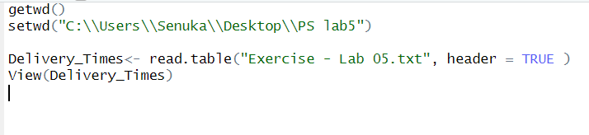

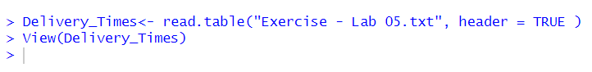

**2. Draw a histogram for deliver times using nine class intervals where the lower limit is 20 and upper limit is 70. Use right open intervals**

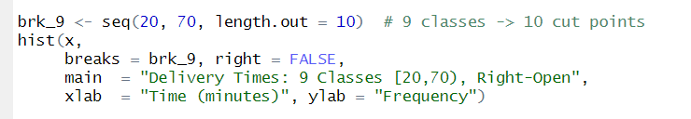

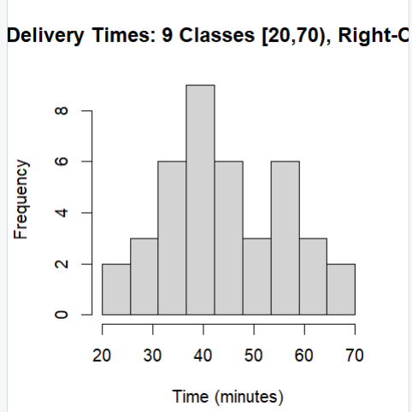

**3. Comment on the shape of the distribution.**

“Distribution is unimodal with a mild right tail (slightly right-skewed) higher-minute bins taper gradually, indicating longer tail to the right.”

**4. Draw a cumulative frequency polygon (ogive) for the data in a separate plot.**

